Creation of tables
CREATE TABLE clientMaster (
clientNo VARCHAR(6) PRIMARY KEY CHECK (clientNo LIKE 'C%'),
name VARCHAR(60) NOT NULL,
address1 VARCHAR(30),
address2 VARCHAR(30),
city VARCHAR(15),
pinCode INT,
state VARCHAR(15),
balDue DECIMAL(10,2) NOT NULL CHECK (balDue <> 0)
)

CREATE TABLE productMaster (
productNo VARCHAR(6) PRIMARY KEY CHECK (productNo LIKE 'P%'),
description VARCHAR(15) NOT NULL,
profitPerc DECIMAL(4,2) NOT NULL,
unitMeasure VARCHAR(10) NOT NULL,
qtyOnHand INT NOT NULL,
reorderLvl INT NOT NULL,
sellPrice DECIMAL(8,2) NOT NULL CHECK (sellPrice <> 0),
costPrice DECIMAL(8,2) NOT NULL CHECK (costPrice <> 0)
)

CREATE TABLE salesmanMaster (
salesmanNo VARCHAR(6) PRIMARY KEY CHECK (salesmanNo LIKE 'S%'),
salesmanName VARCHAR(20) NOT NULL,
address1 VARCHAR(30) NOT NULL,
address2 VARCHAR(30),
city VARCHAR(20),
pinCode INT,
state VARCHAR(20),
salAmt DECIMAL(8,2) NOT NULL CHECK (salAmt <> 0),
tgtToGet DECIMAL(6,2) NOT NULL,
ytdSales DECIMAL(6,2) NOT NULL,
remarks VARCHAR(60)
)

CREATE TABLE salesOrder (
orderNo VARCHAR(6) PRIMARY KEY CHECK (orderNo LIKE 'O%'),
clientNo VARCHAR(6) REFERENCES clientMaster(clientNo),
orderDate DATE,
delyAddr VARCHAR(25),
salesmanNo VARCHAR(6) REFERENCES salesmanMaster(salesmanNo),
delyType CHAR(1) CHECK (delyType IN ('P', 'F')),
billedYn CHAR(1) CHECK (billedYn IN ('Y', 'N')),
delyDate DATE,
orderStatus VARCHAR(10) CHECK (orderStatus IN ('In Process', 'Fulfilled', 'Backorder', 'Cancelled'))
)

CREATE TABLE salesOrderDetails (
orderNo VARCHAR(6) REFERENCES salesOrder(orderNo),
productNo VARCHAR(6) REFERENCES productMaster(productNo),
qtyOrdered INT,
qtyDisp INT,
productRate DECIMAL(10,2),
PRIMARY KEY (orderNo, productNo)
)

Inserting Values into Tables
INSERT INTO clientMaster VALUES ('C00001', 'Ivan Bayross', 'Bandra', 'West', 'Mumbai', 400054, 'Maharashtra', 15000)
INSERT INTO clientMaster VALUES ('C00002', 'Hartford Intern', 'Hitech City', 'Mindspace', 'Hyderabad', 500081, 'Telangana', 5000)
INSERT INTO clientMaster VALUES ('C00003', 'UIUX Studio', 'Gachibowli', 'DLF Cyber', 'Hyderabad', 500032, 'Telangana', 12000)
INSERT INTO clientMaster VALUES ('C00004', 'CropData Corp', 'Banjara Hills', 'Rd 12', 'Hyderabad', 500034, 'Telangana', 8500)
INSERT INTO clientMaster VALUES ('C00005', 'To Be Deleted', 'Indiranagar', '100ft Rd', 'Bangalore', 560038, 'Karnataka', 22000)

INSERT INTO productMaster VALUES ('P00001', 'Trousers', 5, 'Piece', 200, 50, 850, 550);
INSERT INTO productMaster VALUES ('P00002', 'Pull Overs', 10, 'Piece', 150, 20, 1200, 800);
INSERT INTO productMaster VALUES ('P00003', '1.44 drive', 15, 'Unit', 50, 10, 500, 300);
INSERT INTO productMaster VALUES ('P00004', 'Core Java Book', 20, 'Book', 100, 5, 2500, 1800);
INSERT INTO productMaster VALUES ('P00005', 'Solar Battery', 5, 'Unit', 80, 20, 5000, 4000);

INSERT INTO salesmanMaster VALUES ('S00001', 'Aman', 'A/14', 'Worli', 'Mumbai', 400002, 'Maharashtra', 3000, 100, 50, 'Good');
INSERT INTO salesmanMaster VALUES ('S00002', 'Ravi', 'B/12', 'Madhapur', 'Hyderabad', 500081, 'Telangana', 4500, 200, 150, 'Excellent');
INSERT INTO salesmanMaster VALUES ('S00003', 'Priya', 'C/09', 'Kondapur', 'Hyderabad', 500084, 'Telangana', 4000, 150, 120, 'Good');
INSERT INTO salesmanMaster VALUES ('S00004', 'Kiran', 'D/55', 'Whitefield', 'Bangalore', 560066, 'Karnataka', 3500, 120, 80, 'Average');
INSERT INTO salesmanMaster VALUES ('S00005', 'Amit', 'E/21', 'Koramangala', 'Bangalore', 560034, 'Karnataka', 3200, 100, 90, 'Good');

INSERT INTO salesOrder VALUES ('O19001', 'C00001', '2002-01-12', 'Mumbai', 'S00001', 'F', 'N', '2002-01-20', 'In Process');
INSERT INTO salesOrder VALUES ('O19002', 'C00002', '2025-11-25', 'Hyderabad', 'S00002', 'P', 'Y', '2025-11-30', 'Fulfilled');
INSERT INTO salesOrder VALUES ('O19003', 'C00002', '2025-12-24', 'Hyderabad', 'S00003', 'F', 'Y', '2025-12-31', 'Fulfilled');
INSERT INTO salesOrder VALUES ('O19004', 'C00005', '2002-04-15', 'Bangalore', 'S00005', 'F', 'N', '2002-05-10', 'Backorder');
INSERT INTO salesOrder VALUES ('O19005', 'C00003', '2026-01-02', 'Hyderabad', 'S00002', 'P', 'N', '2026-01-10', 'In Process');

INSERT INTO salesOrderDetails VALUES ('O19001', 'P00001', 4, 4, 850);
INSERT INTO salesOrderDetails VALUES ('O19002', 'P00002', 2, 2, 1200);
INSERT INTO salesOrderDetails VALUES ('O19002', 'P00004', 1, 1, 2500);
INSERT INTO salesOrderDetails VALUES ('O19003', 'P00005', 10, 5, 5000);
INSERT INTO salesOrderDetails VALUES ('O19004', 'P00003', 2, 2, 500);

- Display the names of all the clients.
SELECT name FROM clientMaster
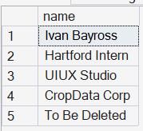

- Display all the clients who are located in Mumbai.
SELECT * FROM clientMaster WHERE city = 'Mumbai';

- Display all the products whose selling price is > 2000 and < 5000.
SELECT * FROM productMaster WHERE sellPrice > 2000 AND sellPrice < 5000

4. Display Name, City and State of Clients not in the state of Maharashtra.
SELECT name, city, state FROM clientMaster WHERE state <> 'Maharashtra'
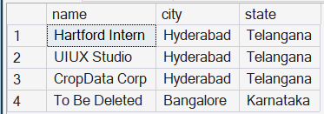

5. Display all the information of client_no C0001 and C0002.
SELECT * FROM clientMaster WHERE clientNo IN ('C00001', 'C00002')
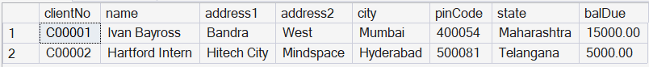

6. Change the selling price of '1.44 drive' to Rs. 1150.50.
UPDATE productMaster SET sellPrice = 1150.50 WHERE description = '1.44 drive'

7. Delete the record of clientNo C0005.
DELETE FROM clientMaster WHERE clientNo = 'C00005'
8. Display the clients who stay in a city whose second letter is 'a'.
SELECT * FROM clientMaster WHERE city LIKE '_a%'

9. Count the number of products having price greater than or equal to 1500.
SELECT COUNT(*) FROM productMaster WHERE sellPrice >= 1500
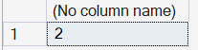

10. Display qtyOrdered, qtyDisp and balancedQty.
SELECT qtyOrdered, qtyDisp, (qtyOrdered - qtyDisp) AS balancedQty FROM salesOrderDetails
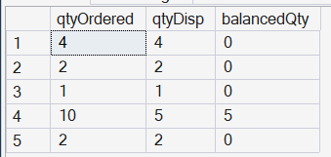

1. Make clientNo as primary key in clientMaster.
ALTER TABLE clientMaster ADD CONSTRAINT pk_client PRIMARY KEY (clientNo)

2. Add a new column phoneNo in the clientMaster table.
ALTER TABLE clientMaster ADD phoneNo NUMERIC(10)

3.Add the not null constraint in productMaster.
ALTER TABLE productMaster ALTER COLUMN description VARCHAR(15) NOT NULL
ALTER TABLE productMaster ALTER COLUMN profitPerc DECIMAL(4,2) NOT NULL
ALTER TABLE productMaster ALTER COLUMN sellPrice DECIMAL(8,2) NOT NULL
ALTER TABLE productMaster ALTER COLUMN costPrice DECIMAL(8,2) NOT NULL

4. Change size of name column to 60 in clientMaster table.
ALTER TABLE clientMaster ALTER COLUMN name VARCHAR(60);

5. Remove pinCode column from table.
ALTER TABLE clientMaster DROP COLUMN pinCode;

1. Recursive Relationship
Definition: A relationship where a table is related to itself.
Example:
SELECT e.name AS employee, m.name AS manager
FROM employeeMaster e
LEFT JOIN employeeMaster m ON e.managerId = m.empId;

2. Composite Key
Definition: A Primary Key that consists of two or more columns to uniquely identify a record.
Example:
CREATE TABLE salesOrderDetails (
orderNo VARCHAR(6),
productNo VARCHAR(6),
PRIMARY KEY (orderNo, productNo) -- Both columns make the unique key
)
3. The 'LIKE' operator with pattern matching
Definition: Used in a WHERE clause to search for a specified pattern in a column.
Example:
Finds clients whose city starts with 'M'
SELECT * FROM clientMaster WHERE city LIKE 'M%';
4. Drop Table command
Definition: A DDL command that removes the table definition and all its data, indexes, and constraints permanently from the database.
Example:
DROP TABLE clientMaster;
5. Full Outer Join
Definition: Returns all records when there is a match in either the left or right table records. returns NULL where there is no match.
Example:
SELECT c.name, o.orderNo
FROM clientMaster c
FULL OUTER JOIN salesOrder o ON c.clientNo = o.clientNo;

1. Products sold to "Ivan Bayross".
SELECT pm.productNo,pm.description FROM productMaster pm
JOIN salesOrderDetails sod ON sod.productNo = pm.productNo
JOIN salesOrder so ON so.orderNo = sod.orderNo
JOIN clientMaster cm ON cm.clientNo = so.clientNo
WHERE cm.name = 'Ivan Bayross'
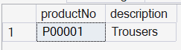

2. Products to be delivered in the current month (Using GETDATE).
SELECT pm.productNo,pm.description FROM productMaster pm
JOIN salesOrderDetails sod ON sod.productNo = pm.productNo
JOIN salesOrder so ON so.orderNo = sod.orderNo
WHERE MONTH(so.delyDate) = MONTH(GETDATE())
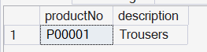

3. Constantly sold products.
SELECT pm.productNo,pm.description FROM productMaster pm
JOIN salesOrderDetails sod ON sod.productNo = pm.productNo
GROUP BY(pm.productNo),(pm.description)
HAVING COUNT(sod.orderNo) >= 1
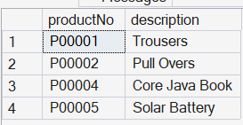

4. Clients who purchased 'Trousers'.
SELECT c.name FROM clientMaster c
JOIN salesOrder so ON so.clientNo = c.clientNo
JOIN salesOrderDetails sod ON sod.orderNo = so.orderNo
JOIN productMaster pm ON pm.productNo = sod.productNo
WHERE pm.description = 'Trousers'
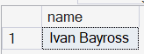

5. Orders with less than 5 units of 'Pull Overs'.
SELECT c.name FROM clientMaster c
JOIN salesOrder so ON so.clientNo = c.clientNo
JOIN salesOrderDetails sod ON sod.orderNo = so.orderNo
JOIN productMaster pm ON pm.productNo = sod.productNo
WHERE pm.description = 'Pull Overs' AND sod.qtyOrdered < 5
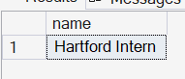

SUB QUERIES
1. Finding the non-moving products.
SELECT description FROM productMaster
WHERE productNo NOT IN (select DISTINCT productNo FROM salesOrderDetails)
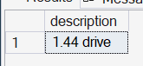

2. Finding address for Order number 'O19001'.
select delyAddr from salesOrder
where orderNo = '019001'
or
select name,address1, city FROM clientMaster
where clientNo = (select clientNo from salesOrder where orderNo ='O19001') 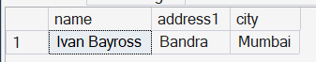

3.
select name from clientMaster
where clientNo = (select DISTINCT clientNo from salesOrder where orderDate < '2002-05-01')
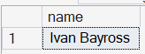

1. Display system date as Saturday, February 11, 2012
select FORMAT(GETDATE(),'dddd,MMMM dd,yy')
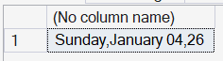

2.
SELECT FORMAT(balDue, 'C', 'en-US')
FROM clientMaster;
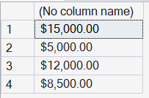

3.
SELECT 'Salesman ' + salesmanName + ' sold goods of ' + CAST(ytdSales AS VARCHAR) + ' while given target was ' + CAST(tgtToGet AS VARCHAR)
FROM salesmanMaster
WHERE salesmanName = 'Aman';
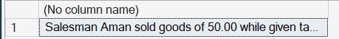

4. SELECT DATEDIFF(YEAR, '2005-06-26', GETDATE());
